REPUBLIQUE DU CAMEROUN

Paix -travail-patrie



**One Love, One Mind, One Legacy!**

linkedIn: shaderl

Tel: (237) 678 358 509 / (237) 692 199 722

Site Web: [www.shaderl.com](https://www.shaderl.com/)

REPUBLIQUE OF CAMEROON

Peace-work-fatherland



**AFRICAN INSTITUTE OF COMPUTERS SCIENCES**

BP: 13 719 Yaoundé (Cameroun)

Tel: (237) 22 72 99 57 / (237) 22 72 99 58

Site Web: [www.iaicameroun.com](http://www.iaicameroun.com)

INTERNSHIP REPORT

THEME : CONCEPTION AND IMPLIMENTATION OF AN AGRIFUTURE INVEST PLATFORM

Carried out from the 1st of July 2025 to the 30th of September 2025 in view of obtaining a HTD in Software Engineering

**Written By**

**SOMO REAN GIGGIS KINYUY**

LEVEL 2

AICS CAMEROON

**PROFESSIONAL SUPERVISOR**

Mr. AE Derick

C.E.O of SHADERL

**ACADEMIC SUPERVISOR**

Mme TCHOUCHOUO

Lecturer at AICS

**ACADEMIC YEAR 2024-2025**

# DEDICATION

TO THE WIRNKAR’S FAMILY

# ACKNOWLEDGEMENTS

My gratitude goes to the following people who assisted in the realization of this project:

* The Resident Representative of AICS-Cameroon, Mr. Armand Claude ABANDA, for his words of encouragement and the different advices brought to us.
* Our professional supervisor, Mr. AGBOR ANDERSON for the numerous advices and professional expertise shared with us.
* Our academic supervisor Mrs. TCHOUTOUO ISABELLE for her support and help in the realization of the internship report.
* To our teachers for their numerous advices and guidance throughout the academic year.
* To my beloved parents MR & MRS WIRNKAR for their endless love, moral and financial support.
* To my brother ASHERY ALEXENDA and my sister MARY SAMANTA for their love and care regarding my studies.
* To our academic seniors: ASANE DERICK, CHRIS ANDERSON, LUCRESS NADIN for their academic support.
* To MR AGBOR ANDERSON for the love, support and great concern in helping me become a better person.
* To MR MESSIO for the numerous motivations and great contribution in the realization of this application.
* To Mr. AGBOR ANDERSON for the daily encouragements he brought to me.
* To all our classmate for their support and collaborative work throughout the academic year.

# SUMMARY

# LIST OF FIGURES

# LIST OF TABLES

# GLOSSARY

# ABSTRACT

# RESUME

# GENERAL INTRODUCTION

To bridge the gap between theory and practice, second-year students at **AICS Cameroon** are required to undertake a **three-month academic internship** in an enterprise. This internship enables them to apply the knowledge acquired in class within a professional environment.

For this reason, we applied for an internship at **SHADERL**, a company that specializes in providing software solutions. During our stay at SHADERL, we were assigned the project theme: **“Conception And Implimentation Of An Agrifuture Invest Platform.”**

This report documents the entire process of the internship and the development of the AgriFuture Invest Platform. The platform is aimed at revolutionizing the agricultural investment ecosystem by connecting farmers, firms, and investors through a transparent and interactive digital solution. We divided this report into 2 parts which is as follows:

**PART I:** **The Insertion phase:** This book presents the company in which we spent our internship period and the integration of interns

**PART II:** **Technical phase:** which is composed of the following

* **PHASE I:** Existing System: Here, we shall present the already present system in place, that is the one used for consultation and follow-up purposes.
* **PHASE II:** The specification book: In this book, we specify the needs of the user taking into considerations the time and cost of the project.
* **PHASE III:** Analysis book: Here, we present the analysis method chosen with the
* presentation of all the diagrams used for the analysis of this project.
* **PHASE IV:** Design phase: This presents the generic and detailed conception of the project to bring out real world constituents.
* **PHASE V:** Deployment phase: This phase will permit us to visualize the implementation process of the solution
* **PHASE VI:** Test of functionalities: In this phase, we shall present to you the different functionalities or modules of our application and how they work.
* **PHASE VII**: user guide: which guide the user on how to install and use the application

# PART I : INSERTION PHASE

## Preamble

This section of the report will cover details of how we were welcomed in the host company, presentation, organization and brief introduction to our project.

## Content

INTRODUCTION

1. WELCOME AND INSERTION
2. GENERAL PRESENTATION OF THE COMPANY
3. ORGANIZATION OF THE COMPANY
4. GEOGRAPHICAL LOCATION
5. BRIEF PRESENTATION OF PROJECT THEME

CONCLUSION

## INTRODUCTION

The insertion phase in a company is a period during which we discover our working environment, the staff of the company and other interns. Here, we will begin by discussing our first two weeks in the company, how we were welcomed and how we began adapting to our internship environment, we will proceed by exploring the history of the company, discovering its missions, learning what its major activities are, and witnessing some of its key realizations. We will also get to understand how the company is structured administratively and functionally so that it operates effectively and accomplishes its goals. Furthermore, we will look at the hardware equipment used by the company, and the software resources used in its daily operations. We will then introduce our chosen theme for the internship period, briefly elaborate on It.

## I-WELCOME AND INSERTION

We arrived at SHADERL on Tuesday 01st July 2025, at 08:00 a.m. we were received by the shaderl team who introduced us to our workspace, gave us an official welcome to the enterprise, its activities and its different rules and regulations. Also, we discussed on the enterprise’s preferred languages and frameworks, our professional supervisor encouraged us through his past working experiences in different enterprises.

The first two week we started with our internship report by configuring our MS WORD processor, reviewing key concepts like page numbering, styles, section breaks, page breaks etc. There was a talk on project ideas, we were advised to propose project ideas and we were assigned the tasks to carry out research on these ideas. The objective was that the enterprise did not want to impose some themes on us. For those who could not find a theme, the enterprise could propose an idea for them to think about.

## II-GENERAL REPRESENTATION OF SHADERL

A-Background:

Shaderl is a dynamic, non-governmental tech startup founded in 2023 by **Asane Derick** with a bold vision: to bridge the gap between traditional industries and the rapidly evolving digital economy. Recognizing the urgent need for digital transformation, Shaderl is committed to providing **cutting-edge IT solutions** while empowering the next generation of innovators.

### B- Mission

At Shaderl, we harness the power of **AI and cutting-edge technology** to democratize digital transformation. Our mission is to **empower individuals and businesses** with intelligent tools, accessible education, and personalized mentorship bridging the gap between today’s potential and tomorrow’s opportunities. We believe AI should **augment human potential, not replace it**. By making AI-driven solutions practical and ethical, we equip the next generation to lead, innovate, and thrive in an era where **human creativity meets machine intelligence**.

### C-Vision

At Shaderl, we envision a world where **technology unites humanity**, where innovation is driven by collective purpose, not just profit. By putting **“PeopleFirst”**, we strive to build a future where:

* **One Love**→ Technology fosters **inclusion, empathy, and global collaboration**, breaking down barriers.
* **One Mind**→ AI and digital tools **amplify human potential**, creating shared knowledge and opportunity.
* **One Legacy**→ Every individual we empower leaves a lasting impact, shaping a **smarter, kinder, and more connected world**.

We don’t just adapt to the digital age; we **redefine it with humanity at the core**.

### D- ACTIVITIES

The activities of SHADERL range from computer sciences, engineering, and training. We can outline the following:

➢ Conception realization, and hosting of websites.

➢ Software development and maintenance.

➢ Training in Software related fields.

➢ Conception and realization of multimedia.

➢ IT consulting and innovation.

➢ IT support.

## III-ORGANISATION OF SHADERL

Shaderl is administratively organized as follows:

a- Executive Leadership

**This department is responsible for:**  
✓ Setting the company's vision, mission, and strategic direction  
✓ Making high-level decisions about investments, partnerships, and growth  
✓ Representing Shaderl in key meetings with investors and government agencies  
✓ Ensuring all departments align with the company's core values and objectives  
✓ Overseeing the overall performance and sustainability of the organization

b. Software Engineering Department  
 **This department is responsible for:**  
✓ Designing, developing, and maintaining all of Shaderl's software products  
✓ Implementing AI and machine learning solutions for company offerings  
✓ Ensuring software security, scalability, and optimal performance  
✓ Collaborating with other departments to understand technical requirements  
✓ Staying updated with emerging technologies and industry best practices

### c. Human Resource Department

**This department is responsible for:**  
✓ Recruiting and onboarding top talent that aligns with Shaderl's values  
✓ Managing employee relations, welfare, and performance evaluations  
✓ Developing training programs to enhance staff skills and capabilities  
✓ Maintaining company culture and ensuring a positive work environment  
✓ Handling compensation, benefits, and conflict resolution

### d Communication Department

**This department is responsible for:**✓ Managing Shaderl's public image and brand reputation  
✓ Developing and executing marketing and PR strategies  
✓ Handling all internal and external communications  
✓ Managing social media platforms and digital content  
✓ Organizing corporate events and press engagements

### e Department of Financial Affairs

**This department is responsible for:**✓ Managing all financial operations and accounting  
✓ Preparing budgets and financial forecasts  
✓ Handling payroll, taxes, and financial reporting  
✓ Ensuring compliance with financial regulations  
✓ Managing investments and financial partnerships

B- Functional organisation

The functional branch of shaderl is organized as follows:

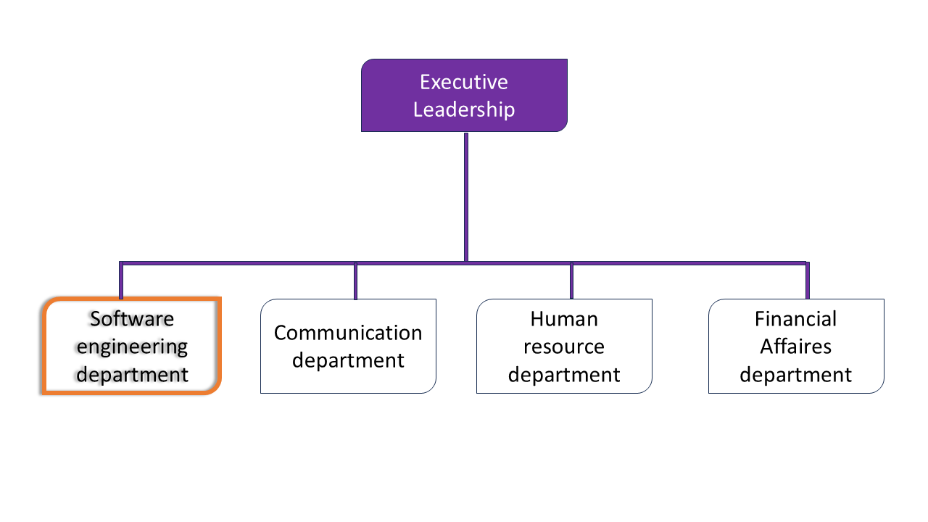

## IV- GEOGRAPHICAL LOCATION

### 1. History

The **SHADERL** project was born from a spark of genius during the third-year engineering internship of **Mr. SANAMA Léopold Armel** at **IAI-Cameroon**. The idea matured into a real-world venture, and in **February 2025**, it officially became a registered entity with **SARL (Limited Liability Company)** status.

In its early days, SHADERL focused on training young students from universities and professional institutions, equipping them with practical skills to build high-quality software products for the Cameroonian society. Over time, SHADERL gained recognition for its commitment to youth empowerment, innovation, and software excellence.

Today, SHADERL partners with numerous young professionals and continues to spearhead diverse technology-driven projects across Cameroon.

### 2. Location

SHADERL is located in **Yaoundé**, near **Marie Albert**. The company’s premises are easily accessible by road, and the map below illustrates its exact location for ease of navigation:

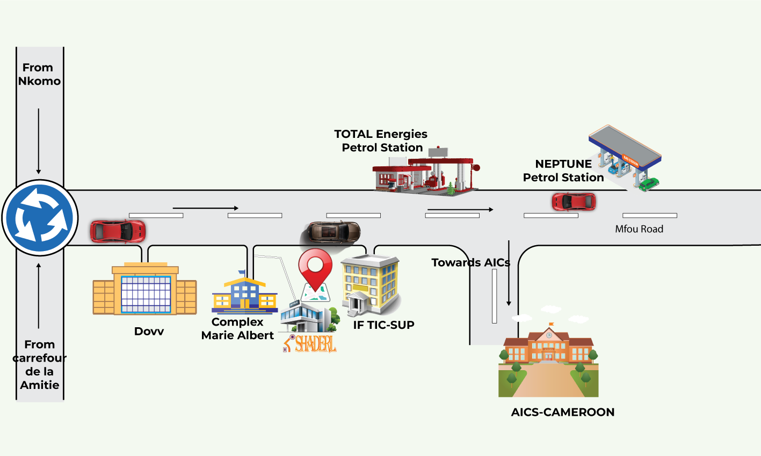

## V- BRIEF PRESENTATION OF THE PROJECT THEME

Upon our arrival at **SHADERL**, we were encouraged to propose potential project ideas for our internship. In line with SHADERL’s mission to actively contribute to the development of innovative software solutions, we identified an opportunity to explore our creativity and proposed the theme: **“Design and Implementation of an AgriFuture Invest Platform.”**

This platform aims to bridge the gap between firms and potential investors by providing a transparent, secure, and user-friendly investment system tailored to the agricultural sector. The system is composed of several modules:

**Admin Dashboard**: Responsible for the management of platform users, including the creation of investor and farmer accounts, approval of project listings, and system-wide settings.

**Investor Dashboard**: Allows investors to view agricultural projects, access detailed proposals, track investment performance, and receive updates or reports from farmers.

**Farmer Dashboard**: Enables farmers and agricultural startups to register their projects, upload funding proposals, share updates, and interact with potential investors.

**Public Home Interface**: Offers general visitors the ability to browse featured agricultural projects, view statistical insights, and learn about investment opportunities before signing up.Through this platform, we aim to support digital transformation in agriculture and empower both farmers and investors with a reliable tool for funding and development.

## CONCLUSION

Our insertion phase at **SHADERL** lasted for a period of **two (2) weeks**. During this time, we familiarized ourselves with the company's working environment, which was well-structured and equipped with the necessary tools to promote hard work, productivity, and collaboration.

We took time to understand the **mission** of the company and its various **ongoing activities**, which revolve around the development of innovative software solutions tailored to societal needs. We were also introduced to other interns with whom we engaged in collaborative tasks, fostering teamwork and knowledge exchange.

At the end of this orientation period, we collectively decided on our project theme: **“Design and Implementation of an AgriFuture Invest Platform.”** This marked the beginning of our practical journey toward building a digital solution aimed at revolutionizing investment in the agricultural sector.

# PART II : TECHNICAL PHASE

## Preamble

The technical phase is a document that describes the process, progress, or results of a scientific research. It also includes a detailed analysis and the conclusions drawn from that research.

**PHASE** I: THE EXISTING SYSTEM

**PHASE** II: THE SPECIFICATION BOOK

**PHASE** III: THE ANALYSIS PHASE

**PHASE** IV: CONCEPTION PHASE

**PHASE** V: REALIZATION PHASE

**PHASE** VI: TEST OF FUNCTIONALITIES

**PHASE** VII: USER GUIDE

# **PHASE** I : THE EXISTING SYSTEM

## Preamble

The existing system is a document that provides a view of how the current system works, how it carries out its different activities, it equally provides a deep understanding of the system associated to the various limitations and the problems that result from it and we propose the solution.

## Content

TRODUCTION

1. PRESENTATION OF THE PROJECT THEME
2. STUDY OF THE EXISTING SYSTEM
3. CRITICISMS OF THE EXISTING SYSTEM
4. PROBLEMATICS
5. PROPOSED SOLUTION

## INTRODUCTION

As Engineers our role in the society is problem-solving which is targeted at making life easier for everyone and in order to bring forth a solution, we ought to ask ourselves some questions to know why the problem exist in the first place and how it is being dealt with at a time. The existing system refers to the system put in place to carry out the work done in the field on which our theme is based. Understanding this system is a great step in solving the problems that we might identify. It’s of great importance that we take into consideration this system before proposing a suitable solution that will ameliorate or replace the current one.

## I. Presentation of the Project Theme

In a world where agriculture remains a vital pillar of economic development—especially in Cameroon—smallholder farmers, agricultural startups, and agribusinesses often struggle to access sufficient funding and visibility. At the same time, many investors are seeking reliable and impactful opportunities to support sustainable ventures. Bridging this gap is essential for national development, food security, and youth engagement in agriculture.

To address this need, we proposed the project theme:  
**“Design and Implementation of an AgriFuture Invest Platform.”** This platform is intended to serve as a **digital bridge between agricultural entrepreneurs and potential investors**. It is a web-based application that will enable farmers and agribusiness project owners to showcase their initiatives, submit investment proposals, and connect with interested funders.

The main objectives of the platform include:

* Creating a **centralized database** of verified agricultural projects seeking investment.
* Allowing investors to **browse, assess, and fund** promising agricultural initiatives
* Providing **transparency and accountability** through project tracking, reporting, and communication tools.
* Supporting **economic inclusion** by giving access to funding for rural and emerging farmers who often face financing barriers.

In situations where a project owner requires guidance on how to present or manage a project for investment, the platform will also provide access to **advisors or agri-orientators**—professionals who can help shape business models, improve proposals, and recommend pathways for success.

By fostering collaboration between agriculture and technology, the AgriFuture Invest Platform will help drive innovation, reduce investment risk, and promote the growth of sustainable agribusiness in Cameroon and beyond.

## II. Description of the Existing System

In the current agricultural investment ecosystem, the connection between investors and agricultural entrepreneurs in Cameroon remains weak, informal, and largely inefficient. Traditional methods used by farmers and agribusiness startups to seek funding include physical visits to financial institutions, informal requests through personal networks, and occasional presentations at agricultural fairs or workshops. These methods are **time-consuming, geographically limited**, and often **lack transparency** and **structure**.

On the other hand, investors interested in supporting agricultural ventures often face challenges such as:

* **Limited access to reliable project proposals**
* **Lack of credible platforms to evaluate risks**
* **No centralized system for follow-up and reporting**
* **Concerns over the accountability and traceability of their funds**

Currently, there is **no dedicated digital platform** that brings together investors and agricultural project owners in a structured, interactive, and secure manner. Most agricultural financing platforms that exist either target large agribusinesses or focus on loan-based financing, excluding smallholder farmers and startups from the ecosystem.

Moreover, farmers in rural areas often lack the technological tools and support systems to promote their projects to potential sponsors or partners. This results in a **missed opportunity for agricultural innovation, job creation**, and **sustainable food production**.

The absence of a centralized digital solution limits the growth of agriculture as a business sector, discourages private investment, and restricts youth participation in agritech innovations.

Therefore, there is a critical need for a modern solution that enables **visibility, connectivity, accountability, and financial flow** between investors and project owners—hence the motivation for the **AgriFuture Invest Platform**.

## III. Criticism of the Existing System

After collecting and analyzing information regarding existing systems for agricultural investment and support, we identified several **key weaknesses** that hinder their effectiveness. These limitations have practical consequences for both farmers and investors, and if not addressed, they will continue to slow down progress in the agricultural sector.

The table below presents a summary of the identified **limitations**, their **consequences**, and **proposed solutions**:

#### Table 3: Limitations, Consequences, and Solutions of the Existing System

| **Limitations** | **Consequences** | **Proposed Solutions** |
| --- | --- | --- |
| Lack of accessible information on viable projects | - Investors unaware of opportunities- Projects remain underfunded | Create a platform that lists and showcases verified agricultural projects |
| Absence of professional investment advisors | - Investors lack guidance- Farmers struggle to prepare proper proposals | Integrate expert advisors or “agri-orientators” to support both farmers and investors |
| No centralized concours or grant notifications | - Missed opportunities- Mismatch between project goals and funding rounds | Implement notification boards for upcoming grant opportunities and government support |
| Poor decision-making tools for investors | - Risk of funding low-impact or unfeasible projects | Include performance analytics, success metrics, and review systems in the platform |
| Farmers unaware of required standards | - Project rejection due to poor planning or presentation | Provide templates, guidelines, and training materials on the platform |

## IV. Problematic

Agriculture is a major pillar of economic development in Cameroon, yet many smallholder farmers and agricultural startups face serious challenges in accessing funding to grow their businesses. On the other hand, investors—both local and international—are often unable to find trustworthy and promising agricultural ventures to support.

This leads us to ask the core question:

**"How can we facilitate the connection between agricultural entrepreneurs and potential investors while ensuring transparency, visibility, and accountability in the investment process?"**

The **AgriFuture Invest Platform** seeks to provide a reliable, user-friendly, and secure digital space to address this issue.

## V. Proposed Solution

Following our analysis and criticism of the existing system, we propose to **design and implement a web-based platform** that will:

* **Connect agricultural project owners with investors**, enabling them to showcase their ideas and request funding.
* **Provide a searchable catalog of verified agricultural projects**, with detailed descriptions, goals, locations, and funding needs.
* **Offer a secure and transparent investment system**, where investors can track the progress of the projects they support.
* **Include advisor support (Agri-orientators)** to guide farmers in preparing strong investment proposals and improving project feasibility.
* **Integrate a notification board** to inform users about upcoming agricultural grants, concours, and relevant events.
* **Enable geographic mapping** of projects and farm locations to improve visibility and traceability.
* **Support direct communication** between project owners and investors through in-app messaging or contact requests.

Through this platform, we aim to **boost agricultural innovation, encourage private investment**, and support the **digital transformation of the agricultural sector in Cameroon**.

## Conclusion

Having reached the end of this part of our report, we conducted a thorough analysis of the existing system through research and observations in the agricultural sector. Our findings revealed significant limitations, including lack of access to funding opportunities, poor visibility of promising agricultural projects, and a general absence of structured platforms to connect investors with project owners.

These limitations result in underfunded initiatives, missed opportunities, and slowed progress in agricultural innovation and development. Based on these findings, we proposed practical solutions aimed at addressing each of these issues.

Finally, we introduced our project solution: the **Design and Implementation of an AgriFuture Invest Platform**—a web-based application that bridges the gap between firms and investors. The platform is designed to foster collaboration, increase transparency, and enhance the agricultural investment ecosystem in Cameroon.

# **PHASE** II : SPECIFICATION BOOK

## Preamble

The Specification book is a document which is been established by the customer needing a particular product and the producer (engineer) who is to create the product, which is to be respected to its fullness during the realization of the product. From this, we obtain the major importance of the specification book.

INTRODUCTION

I. CONTEXT AND JUSTIFICATION

II. OBJECTIVES OF THE PROJECT

III. EXPRESSION OF NEEDS

IV. PROJECT PLANNING

V. ESTIMATED COST OF THE PROJECT

VI. PROJECT CONSTRAINTS

VII.DELIVERABLES

CONCLUSION

## INTRODUCTION

The specification book of our reports helps us provide details about our theme, to improve our understanding of it and increase the likelihood of it succeeding. To delimitate the scope of our project, we will specify the context of our theme. From the context, we will list the problems we have identified in our context and that we have decided to address throughout the project. After presenting our solution, we will talk about the objective we have set for the project. Also, we will explore the needs to which our system will respond both at the functional and non-functional level. We will then look at the estimated financial requirements for our project, and establish a plan we will follow to complete our project on time. From here we will discuss what is expected of us by the end of the project under the project deliverables.

## I. CONTEXT AND JUSTIFICATION

### A. Context

The agricultural sector plays a vital role in the economic development of Cameroon, employing a large portion of the population and contributing significantly to food security and national income. Despite its importance, the sector continues to face major challenges—one of the most critical being **limited access to investment opportunities** for smallholder farmers, agricultural startups, and rural entrepreneurs.

At the same time, many **potential investors**—both individuals and institutions—are seeking high-impact, sustainable ventures to support, but lack a **reliable and centralized platform** through which they can identify and evaluate viable agricultural projects.

In this context, the **design and implementation of a web-based agricultural investment platform** becomes not just relevant, but essential. The **AgriFuture Invest Platform** aims to bridge this gap by creating a **secure, interactive, and accessible digital space** where agricultural project owners can present their ideas and connect with potential investors across Cameroon and beyond.

### B. Justification

The justification for this project lies in the **inefficiencies and inequities** in the current agricultural financing landscape. Many farmers and agripreneurs lack the tools, exposure, and technical know-how to attract investment or present their projects professionally. Conversely, investors are often unable to discover reliable projects or assess their feasibility due to the absence of standardized presentation platforms.

This platform will:

* Promote **financial inclusion** by giving small-scale farmers access to a broader investor base.
* Encourage **agricultural innovation** by funding projects that would otherwise remain invisible.
* Increase **transparency and trust** in the investment process through project tracking, documentation, and communication tools.
* Support national goals around **youth employment**, **digital transformation**, and **sustainable agriculture**.

The **AgriFuture Invest Platform** is, therefore, not only a technological solution but also a strategic tool for empowering the next generation of agricultural leaders and transforming the way agricultural investments are made in Cameroon.

## II. OBJECTIVES OF THE PROJECT

### A. General Objective

The main objective of this project is to **design and implement a centralized web-based platform** that facilitates **investment in the agricultural sector** by connecting agricultural project owners with potential investors. This platform aims to provide a transparent, secure, and accessible environment where both parties can interact, share resources, and build mutually beneficial partnerships.

### B. Specific Objectives

* **To enable farmers and agripreneurs** to register and showcase their agricultural projects with detailed information, including funding needs, location, and impact goals.
* **To provide investors** with a structured catalog of verified agricultural projects, allowing them to browse, filter, and support the initiatives that align with their interests.
* **To allow administrators** to manage platform users (farmers and investors), approve project listings, and monitor platform activity for quality control and transparency.
* **To support agri-orientators or advisors**, who will guide project owners in presenting their proposals effectively and assist investors in making informed decisions.
* **To integrate a notification board** that regularly updates users on grant opportunities, agricultural events, government concours, and other sector-related news.
* **To include communication tools** such as messaging or appointment booking, allowing real-time interaction between investors, farmers, and advisors.

## III. EXPRESSION OF NEEDS

### 1. Functional Needs

Functional needs describe the actions and capabilities available to different users of the system. For the **AgriFuture Invest Platform**, these needs include the following:

**System Administrator**

* **Create Accounts:** Responsible for creating accounts for investors, farmers, and advisors (agri-orientators).
* **Manage Accounts:** Ability to activate, suspend, delete, or block user accounts to maintain platform security and quality.
* **User Authentication:** Enable users to register and securely log into the platform.

**Farmers / Agricultural Project Owners**

* **Register and Manage Projects:** Ability to create, update, and manage detailed profiles of their agricultural projects including funding needs, goals, and location.
* **Edit Profiles:** Update personal and project information to facilitate communication with investors.
* **Communicate:** Send and receive messages to and from potential investors or advisors.

**Investors**

* **Browse Projects:** Search and filter agricultural projects based on criteria such as location, crop type, funding amount, and risk level.
* **Invest & Track:** Initiate investments and track project progress and reports through the platform.
* **Communicate:** Connect with project owners or advisors for further inquiries.

**Advisors (Agri-Orientators)**

* **Edit Profiles:** Add relevant information and credentials to facilitate trust and communication.
* **Support Projects:** Review project proposals, provide recommendations, and validate farmer submissions.
* **Manage Appointments:** View, accept, or decline consultation requests from farmers or investors.

### 2. Non-Functional Needs

Non-functional requirements define the overall qualities, characteristics, and constraints of the software system, focusing on **how** the system operates rather than specific functions.

**Performance**

The platform should respond promptly to user actions, ensuring minimal waiting time even under high user load or simultaneous transactions. Fast response times will enhance user experience and engagement.

**Reliability and Availability**

* The application must ensure **high uptime** with minimal downtime to provide consistent and uninterrupted access to users.
* Robust error handling and recovery mechanisms should be in place to maintain platform stability.

**Usability**

* The platform should feature a **user-friendly interface (UI)** that is intuitive and easy to navigate for all users, including farmers, investors, and advisors.
* Accessibility considerations should be integrated to accommodate users with varying levels of technical proficiency.

**Maintainability**

* The codebase should be clear, modular, and well-documented to facilitate easy future development, debugging, and enhancement.

**Security**

* The platform must implement strong security measures to protect sensitive user data and financial transactions.

Key security principles to uphold include:

* **Confidentiality:** Ensuring user data and communications are private.
* **Integrity:** Protecting data from unauthorized modification.
* **Authentication:** Verifying the identity of users to prevent unauthorized access.

These non-functional needs are critical to building a trusted, efficient, and scalable platform that supports the growing agricultural investment ecosystem.

## IV. PROJECT PLANNING

### a. Chronogram of Activities

| **Phase** | **Objective** | **Output** | **Duration Period** |
| --- | --- | --- | --- |
| **Insertion** | Collecting information about the enterprise | Insertion report/book | 2 weeks (2th to 15nd July 2025) |
| **Existing System** | Study of the existing system | Existing System Analysis | 1 week (16nd to 22th July 2025) |
| **Specification Book** | Specification of user needs | Specification Document | 5 days (23th to 27th July 2025) |
| **Analysis** | System analysis | Analysis Report | 2 weeks (28th  July to 10th August 2025) |
| **Conception** | Hardware and software design | Conception Document | 2 weeks (11th to 24th August 2025) |
| **Realization** | System development | Developed System | 3 weeks (25th August to 14th September 2025) |
| **Testing & Debugging** | System testing and debugging | Tested and Debugged Software | 1 week (15th to 27th September 2025) |
| **Writing User Guide** | Creation of user instruction manual | User Guide Document | 1 week (15th to 27th September 2025) |
| **Deployment** | Capture of needs, use case and textual description modeling | Realization Document | 1 week (28thto 30th September 2025) |

### b. Gantt Project Planning

## V. Estimated Cost of Project

### a. Software Resources

| **Resource Designation** | **Usage** | **Quantity** | **Unit Cost (FCFA)** | **Type** |
| --- | --- | --- | --- | --- |
| Microsoft Office | Writing report | 1 | 38,750 | Licensed |
| GitHub | Saving report and source code | 1 | Free (Freemium) | Cloud Storage |
| Google Chrome | Research and viewing application | 1 | Free | Freeware |
| Visual Studio | Writing application code | 1 | Free | Freeware |
| EdrawMax | Drawing geographical location | 1 | Free (Freemium) | Illustrating tool |
| Sybase Power AMC | UML analysis and diagrams | 1 | Free (Freemium) | Modeling tool |
| GanttProject | Building Gantt charts | 1 | Free (Freemium) | Project planning |
| Node Js | Writing backend code | 1 | Free (Freemium) | **JavaScript runtime environment** |
| NoSQL (e.g., MongoDB) | Storing information (database) | 1 | Free (Freemium) | Database |
| TOTAL 1 |  |  | 38,750 |  |

### b. Hardware Resources

(Source: [ubuy.cm](https://www.ubuy.cm" \t "/home/fsd/Documents\\x/_new))

| **Resource** | **Usage** | **Quantity** | **Unit Cost (FCFA)** |
| --- | --- | --- | --- |
| Desktop (Model: H6AP3S0) | Drafting reports and coding | 1 | 120,000 |
| Printer HP | Printing the report | 1 | 65,000 |
| Modem (TP-Link) | Network connectivity | 1 | 25,000 |
| USB Key (64GB) | Software installation and sharing | 1 | 7,000 |
| MTN Home Box | Collaborative network connectivity | 1 | 15,000 |
| TOTAL2 |  |  | 232,000 |

### c. Human Resources

(Source: [paylab.com/cm](https://www.paylab.com/cm/salaryinfo/information-technology" \t "/home/fsd/Documents\\x/_new))

| **Role** | **Number of Days** | **Quantity** | **Cost per Day (FCFA)** | **Total Price (FCFA)** |
| --- | --- | --- | --- | --- |
| Project Manager | 91 | 1 | 40,000 | 3,640,000 |
| Analyst | 14 | 1 | 30,000 | 420,000 |
| Designer | 14 | 1 | 20,000 | 280,000 |
| Programmer | 21 | 1 | 15,000 | 315,000 |
| Tester | 13 | 1 | 10,000 | 130,000 |
| Unforeseen Costs | — | — | — | 1,000,000 |
| **Total** |  |  |  | **5,655,000** |

### d. Global Estimation

| **Category** | **Total Cost (FCFA)** |
| --- | --- |
| Software Resources | 38,750 |
| Hardware Resources | 232,000 |
| Human Resources | **5,655,000** |
| Overall Total | 5,925,750 ~ 6,000,000 |
|  | Six million. |

## VI. CONSTRAINTS

**Technical Constraint**  
For the development of the AgriFuture Invest Platform, we have chosen sufficiently robust tools and technologies to ensure a minimum level of security, extensibility, and excellent scalability. During the programming phase, adherence to technical standards will be essential to achieve optimal performance with reduced execution times. Therefore, selecting appropriate development technologies is critical to the project’s success.

**Time Constraint**  
The entire project is planned to be completed within a period of **13 weeks (3 months)**, starting from the project commencement date of **28th July 2024**. This limited timeframe requires effective time management and adherence to the project schedule.

**Cost Constraint**  
The estimated cost of the project is approximately **seven million FCFA**, which may be challenging for the developer (student) to fully fund without external support or sponsorship.

**Integration Constraints**  
The system may rely on third-party APIs or external services that impose usage restrictions or present potential performance limitations. These dependencies could affect the platform’s functionality and must be managed carefully to ensure smooth integration.

## VII. LIST OF PARTICIPANTS AND DELIVERABLES

### A. List of Participants

| **Name** | **Function** | **Role** |
| --- | --- | --- |
| Mr. AE DERICK | C.E.O SHADERL | Professional Supervisor at SHADERL |
| Mrs. TCHOUTOUO Isabelle | Lecturer at AICS Cameroon | Academic Supervisor |
| SOMO REAN GIGGIS KINYUY | Intern at SHADERL | Student at AICS Cameroon |

### B. Deliverables

In project management, any tangible or intangible output that materializes the result of a task or service is referred to as a **deliverable**. For our project, the key deliverables include:

**The Application:** The fully developed and functional AgriFuture Invest Platform, ready for deployment and use.

**The User Guide:** A comprehensive manual providing instructions on how to use the application and its features effectively.

**The PowerPoint Presentation:** A summary presentation highlighting the project objectives, methodology, results, and conclusions for demonstration purposes.

## Conclusion

Having reached the end of this part, the project objectives have been clearly enumerated and defined. The specification book has allowed us to identify the various stakeholders involved in the project, outline the system requirements, and establish a provisional plan necessary for the successful completion of the project.

We will now proceed to the next phase, which is the **analysis phase**. During this phase, we will model our system using a suitable modeling language and unified process methodology. Additionally, we will conduct a comparative study between UML (Unified Modeling Language) and Merise to select the most appropriate approach for our system design.

# **PHASE** III: THE ANALYSIS PHASE

## Preamble

The main objective of the analysis phase is to capture the user’s need, the delimitation of the field of study and to have a clear understanding of the system in study. To achieve this, we will use UML (Unified Modelling Language) with the 2TUP (2 Track Unified Process) as method applied to UML to analyze the system. We will start by doing a comparison between UML and MERISE, of various unified processes and lastly, we will present the modelling of the solution we propose (Our system)

## Content

NTRODUCTION

1. METHODOLOGY
2. COMPARATIVE STUDY OF UML AND MERISE.
3. COMPARATIVE STUDY OF UNIFIED PROCESSES.
4. CHOICE OF THE ANALYSIS METHOD
5. MODELLING OF THE PROPOSED SOLUTION

CONCLUSION

## INTRODUCTION

System development can be viewed as comprising two main components: system analysis and system design. Both are essential for understanding the intricacies of the existing system or the new system being developed. Typically, the analysis and design of information systems aim to facilitate the creation of databases that accurately represent the realities of the studied domain, necessitating the use of a structured design method. Consequently, we have chosen the UML method, as it provides significant advantages for developers seeking a user-centered approach and broad design capabilities. This section of the report will include a comparative study of UML and MERISE, an exploration of unified processes, and an overview of various diagrams that address functional requirements.

## METHODOLOGY

### COMPARATIVE STUDY OF UML AND MERISE

#### MERISE

MERISE stands for “Méthode d’Etude et de Réalisation Informatique pour des Systèmes d’Entreprise”. Although it is prescriptive to some extent, MERISE permits the participation of end users and senior management as well as data processing professionals in its decision cycle. MERISE is a method for designing, developing and carrying out IT projects. The goal of this method is to achieve the design of an information system. The MERISE method is based on the separation of data and processing to be carried out in several conceptual and physical models. The essentials of the approach lie in its three cycles: the decision cycle, the life cycle and the abstraction cycle, which cover data and process elements equally. The separation of data and processing ensures longevity in model. Indeed, the arrangement of data does not have to be often overhauled, while treatments are more frequently.

#### UML

UML (Unified Modelling Language) is a standard notation for the modelling of real-world objects as a first step in developing an object-oriented design methodology. Its notation is derived from and unifies the notations of three object-oriented design and analysis methodologies: Grady Booch's methodology for describing a set of objects and their relationships, James Rumbaugh's Object-Modelling Technique (OMT), Ivar Jacobson's approach which includes a use case methodology. Other ideas also contributed to UML, which was the result of a work effort by Booch, Rumbaugh, Jacobson, and others to combine their ideas, working under the sponsorship of Rational Software. UML captures information about the static and dynamic view of a system. UML 2.5 comprises of 14 diagrams which represent the different views of a system. The 14 diagrams can be subdivided into two, Static or structural and Dynamic diagrams. These diagrams include;

### STATIC OR STRUCTURAL DIAGRAMS

* Class diagram
* Object diagram
* Component diagram
* Deployment diagram
* Composite Structure diagram
* Package diagram
* Profile Diagram

### ii. BEHAVIOURAL OR DYNAMIC DIAGRAMS

* Use case diagrams
* Activity diagram
* State machine diagram
* Sequence diagram
* Communication diagram
* Global Interaction diagram
* Timing Diagram

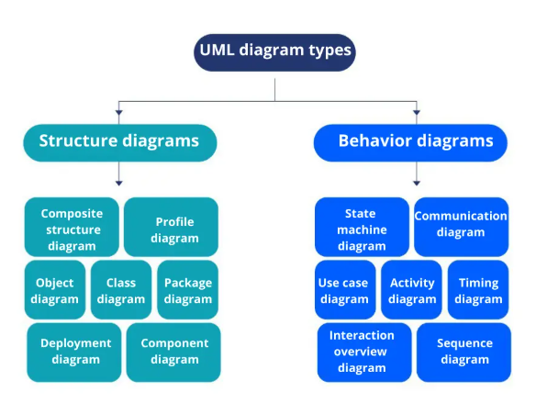

Reference from [Gleek.io](https://www.gleek.io/blog/uml-diagram-types)

On very important notice is that UML is not a method but a modelling language. As such to give it an approach we need to associate UML to a Unified Process (UP) in other to give our conception a methodology to follow. There exist several Unified Processes, but our modelling approach will be the 2TUP (Two-track unified process) which we will use in the course of our project.

|  |  |
| --- | --- |
| **MERISE** | **UML** |
| It stands for Méthode d'Étude et de Réalisation Informatique pour les Systèmes d'Entreprises | Unified Modeling Language |
| MERISE is a systemic method of analysis and design of information systems. That is, it uses a systems approach. | UML is however not a method but rather an object modeling language to which it is necessary to associate an approach to make it a method. This is the case with the 2TUP method; RUP and XP. |
| MERISE proposes to consider the real system from two points of view: - A static view (data) - A dynamic view (treatments). That is, with the MERISE method, we have a separate study of the data and the treatments. | UML offers a different approach from that of MERISE in that it combines data and processing. Because with UML, centralizing the data of a type and the associated processing makes it possible to limit the maintenance points in the code and facilitates access to information in the event of software development. In addition, UML describes the dynamics of the information system as a set of operations attached to the objects of the system. |
| Rational | Object |

### COMPARATIVE STUDY OF UNIFIED PROCESSES

#### A Unified Process

A Unified Process is a process of development of software constructed on UML; it is iterative, incremental, centered on architecture, driven by use cases and requirements.

**Iteration** is distinct sequence of activities with a basic plan and evaluation criterion that produces an internal or external output. Either the content of an iteration is improved, or the evolution of the system is evaluated by users.

**An increment** is the difference between two released products at the end of two iterations. Each iteration that the group is capable of integrating the technical environment in order to develop a final product and give users the possibility of having tangible results.

**Centered on architecture** the different models derived during the establishment of system must be reliable and coherent.

**Driven by use case and requirements** enables the clear definition of a users’ needs and priorities respectively thereby minimizing the risk of project failure.

#### The Two Track Unified Process (2 TUP)

2TUP is a unified process which is built on UML and has as objective to bring solution to constraints of functional and technical changes imposed on information systems by strengthening controls on development capacities. It proposes a Y-sharped development life cycle that separates the functional aspect from the technical aspects, and the merging of these two forms the implementation aspect. 2TUP distinguishes therefore two branches: the functional and technical branches, the combination of the result of these two branches forms the third: the realization branch – where we realize our system. The diagram below illustrates the branches of 2TUP.

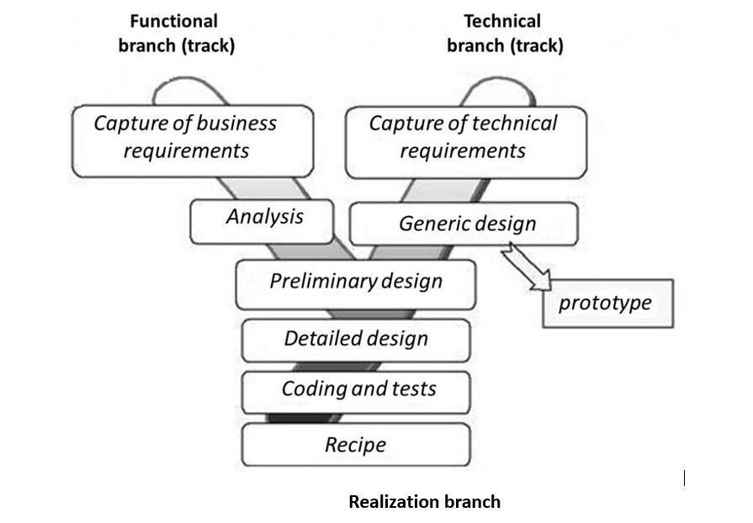

Figure 7: 2TUP diagram (source: [2TUP.COM)](https://www.mysciencework.com/omniscience/pervasive-mobile-healthcare-system-based)

##### The left branch (functional branch)

It captures the functional needs of a system. This ensures the production of software that meets the needs/requirements of the user. The analysis here consists of studying precisely the functional specification in order to obtain an idea of what the system is going to realize, and its result does not depend on any technology.

##### The right branch (Technical branch)

The technical branch enumerates the technical needs and proposes a generic design validated by a prototype. The technical needs include constraints and choices related to the conception of the system, the tools and equipment as well as the integration constraint with the existing system condition.

##### The middle branch (Realization or Implementation branch)

In this branch, we study the preliminary conception, detailed conception, and documentation of the system. The realization branch supports the following:

**Preliminary conception:** This is the most sensitive step of 2TUP as it is the confluence of the functional and technical branch. It is completed when the deployment model, the operating model, the logical model, interphases and the software configuration model are defined. We have the following diagrams:

* Component Diagram
* Deployment Diagram
* Package Diagram
* Composite Structure Diagram

**Detailed conception:** This is the detailed design of each feature of the system. We have the following diagrams:

* Class
* Object
* Sequence
* Timing Diagram

**Coding and testing**: This is the phase where we program the designed features and test the coded features.

**The recipe:** Also known as the deliverables is the validation phase of the functions of the developed system.

## CHOICE OF THE ANALYSIS METHOD

The reason why we chose UML modelling language and the software development process 2TUP instead of many others that exist, include:

UML is the current standard for programming in an object-oriented language. For this reason, it is widely understood and well known making it easy for a new programmer to join the project and be productive from the very first day.

UML diagrams allow teams to virtualize how a project is or will be working, and they can be used in any field, not just software engineering. The diagrams will allow teams to virtualize together how a system, or a process will work or did work. It can provide new ideas for how teams have to collaborate to achieve the goal of the workflow process.

2TUP is centered around the creation and maintenance of a model, rather than the production of mountain documents.

2TUP is user oriented as it permits the development of software that responds to the needs of the users through the study of the user needs.

2TUP is iterative and incremental, hence it enables the project team to produce refined amelioration if necessary and easily integrate it in the already existing system.

2TUP by permitting the project team identify and test the key functionalities of the system limits the risk related to building the system.

## MODELLING OF THE PROPOSED SOLUTION

### Capture of Functional Needs

The first step of the left (functional) branch of Two Track Unified Process (2TUP) is the capture of the functional needs. At this step, we capture the intended behavior of the system that maybe express as services, tasks or functions the system is required to perform.

#### USE CASE DIAGRAM

##### Definition

Use case diagram shows the functionalities of a system, their interdependencies and how they relate with actors of the system. A use case is a specification of behaviour. The main objectives of the use case diagram are:

* Provide a high-level view of the system.
* Identify the functions of the system.

Use case diagrams are completed with a textual description of each use case that is intended to define the use case in greater details.

##### Formalism



Figure 8: Use Case Diagram formalism

##### The Component of the use case Diagram

Table 9: Use Case Diagram Component

|  |  |  |
| --- | --- | --- |
| **Elements** | **Notation** | **Description** |
| Actors |  | Represents an entity that directly interacts with the system. The actor is what performs the different possible actions of the system |
| Use case |  | A use case represents a functionality of the system. It is an action that can be performed by an actor. |
| Association |  | it indicates that an actor takes part in a use Case. |
| Include |  | An inclusion denotes that an included action must be performed before the including action can be performed. |
| Extend |  | An extension denotes that an extending action may be performed while an extended action is being performed. |

|  |  |  |
| --- | --- | --- |
| Generalization |  | This shows that an actor or a use case is a kind of another abstract or concrete actors can be defined and later specialized using generalization relationship. |
| System |  | It is a container of use cases which interact with external actors |

##### The Actors of our System

Table 10: Actors of our System

| **Actor** | **Role** |
| --- | --- |
| **Super Administrator** | Manages the entire platform, including user accounts, project approvals, and system settings. |
| **Farmer / Project Owner** | Registers on the platform, submits agricultural projects for investment, and updates project information. |
| **Investor** | Views available agricultural projects, makes funding decisions, and communicates with project owners. |
| **Agri-Advisor** | Provides expert advice to farmers, validates projects, and assists investors in making informed decisions. |
| **Cloud Storage API** | Used for securely storing documents, project media, and other system files (e.g., NextCloud or Firebase). |
| **SMTP Server** | Sends email notifications to users (e.g., registration confirmation, project approval, investment updates). |

##### General Use Case Diagram

##### Consult document use case diagram

##### Consult workspace use case diagram

##### Consult account list use case diagram

##### Textual description of use cases

#### COMMUNICATION DIAGRAM

##### Definition

Communication Diagrams model the interactions between objects in a sequence. They describe both the static structure and the dynamic behavior of a system. It is a simplified version of a Collaboration Diagram introduced in UML 2.0. A communication diagram is more focused on showing the collaboration of objects rather than the time sequence.

##### Formalism

****

Figure 13: Communication Diagram formalism

##### Components of a Communication Diagram

Table 14: Elements of a communication diagram

|  |  |  |
| --- | --- | --- |
| ELEMENT | NOTATION | DESCRIPTION |
| **Message** |  | Designs a particular communication between lifelines. |
| **Connectors** |  | It represents the relationships that exist between lifelines |

|  |  |  |
| --- | --- | --- |
| **Dependency** |  | A dependency is a relationship that signifies a single or a set of model elements for their specification |
| **Lifeline** |  | An object represents an individual participant in the interaction conversation. |

#### SEQUENCE DIAGRAM

##### Definition

A Sequence diagram describes interactions among classes in terms of an exchange of messages over time. They are also called event diagrams. A Sequence diagram is a good way to visualize and validate various runtime scenarios. These can help to predict how a system will behave and to discover responsibilities a class may need to have in the process of modelling a new system.

##### Formalism

****

Figure 17: Formalism of sequence diagram

##### Components of Sequence Diagram

Table 15: Elements of sequence diagram

|  |  |  |
| --- | --- | --- |
| ELEMENT | NOTATION | DESCRIPTION |
| **Lifelines** |  | They represent rows or objects instances that participate in the sequence being modelled. |
| **Asynchronous Message** |  | It is a message that receives an indirect response. |
| **Synchronous Message** |  | It is a message that sends and want response before it continues a process |
| **Self-Message** |  | self-message can represent a recursive call of an operation, or one method calling another method belonging to the same object. |
| **Return Message** |  | It represents the response of a message. |
| **Actor** |  | They send and receive message. |
| **Combined Interaction Fragment** |  | An articulation of interaction diagram, defined by an operator and operands. |

#### ACTIVITY DIAGRAM

##### Definition

An activity diagram is a graphical representation of workflows that show the steps needed in the realization of a process; showing the details from a start point to an end point through all decisions and actions that can possible be performed. Activity diagrams are intended to model both the computational and organizational process. They flow can be sequential, branched or concurrent. Below is an activity diagram formalism.

##### Formalism

****

Figure 21: Formalism of activity diagram

##### Elements of activity diagrams

Table 16 :The Component of the Activity Diagram

|  |  |  |
| --- | --- | --- |
| Element | Diagrammatic Representation | Description |
| **Activity** |  | Used to represent a set of actions. |
| **Action** |  | Represent a task to be performed. |
| **Activity edge** |  | A directed connection between two activity nodes through which tokens may flow |
| **Initial node** |  | Shows the beginning of an activity or set of actions. |
| **Final node** |  | Stops all controls and object flows in an activity. |
| **Object node** |  | Represents an object connected to a series of object flows. |
| **Decision node** |  | Represents a test condition that slits an incoming activity edge into opposite outgoing activity edges. |
| **Merge node** |  | Reunite different decision  paths created using a decision node. |
| **Fork node** |  | Slits behaviour into parallel or concurrent flows of activities (or actions). |
| **Join node** |  | Unites a set of parallel or concurrent flows of activities or actions. |
| **Swimlane and partition** |  | A way of grouping activities performed by the same actor in an activity diagram or to group actions in the same thread. |

## CONCLUSION

In the analysis phase, we selected a software development process and a modeling language, after which we outlined the functional requirements of our system. We examined the use case diagram, which illustrates the relationships between the actors and the use cases (the actions the actors can perform within the system). We also explored the communication diagram, which depicts the system's architecture based on object-oriented programming principles. Additionally, we analyzed the sequence diagram, which outlines the flow of messages between elements in the system. Finally, we reviewed the activity diagram, which illustrates the workflow of our system. We will now transition to the conception phase, where we will present the technical aspects of our system along with the associated diagrams.